Site name: South East Idaho Weather – www.seidahoweather.com

Site Purpose: The purpose of the site is the provide accurate information on the weather as well as other related topics to individuals in the South East of Idaho or those visiting. The site will specifically provide weather information about Preston, Soda Springs, Fish Haven, and Storm Center. With weather linked closely with outdoor activities a Gallery of images will be included within the site.

Target Audience and Scenarios:

Persona #1: The Farmer

* Age: 25-60
* Education: High School
* Accessing site through home computer
* Looking at the site to determine the coming weather for planting or harvesting their fields.
* “Is it going to rain? What will the humidity levels be that can affect the ground?”

Persona #2: The Athlete

* Age: 15-45
* Education: Ranging from high school to college graduate.
* Accessing site either through laptop or mobile phone.
* Trying to find the weather of the day and how it will influence their workout or sporting activity.
* “Will it be too hot to run outside from 1pm-3pm today?

Persona #3: The Outdoorsmen

* Age: 20-65
* Education: Ranging from high school to college graduate.
* Accessing site through home computer or mobile device.
* Purpose of their visit is to see how the weather will affect their outdoor excursion.
* “Has it been raining around Fish Haven this week? “

Persona #4: Traveler

* Age: 20-40
* Education: Ranging
* Accessing site through mobile phone.
* Purpose it to determine what the weather will be like passing through.
* “Will there be black ice or snow on the road when I’m driving through Preston? Will it be raining or snowing?”

Persona #5: Elderly Local

* Age: 60+
* Education: Ranging
* Accessing through home computer or phone device.
* Purpose is to find out the weather easily.
* “Is the site easy to navigate for someone such as myself who has limited experience with technology?”

Site Map:

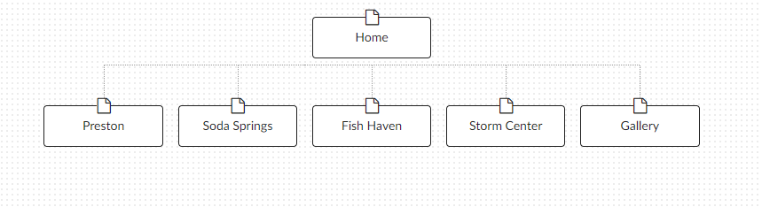

Color Scheme and Typography:

The color scheme will use 4 primary colors; Aqua #6BBAA7, Sunshine #FBA100, Lavender #6C648B and Dusty Rose #B6A19E.

The main will be Lavender.

The menu buttons in the header will be Sunshine.

The weather summary box will be Aqua.

The footer will be Dusty rose.

|  |  |  |  |  |
| --- | --- | --- | --- | --- |
| Site header | Raleway | 40px | #ffffff | Sample |
| Primary Navigation | Raleway | 30px | #ffffff | Sample |
| Footer Navigation | Raleway | 20px | #ffffff | Sample |
| Heading 1 | Raleway | 30px | #ffffff | Sample |
| Heading 2 | Raleway | 25px | #ffffff | Sample |
| Heading 3 | Raleway | 20px | #ffffff | Sample |
| Paragraph text | Raleway | 16px | #000000 | Sample |